1) Title: Filter dropdown menu misaligned and cut off
Description: The filter drop-down menu on the Products page is not properly aligned with the icon and appears partially cut off from the right side of the screen, which affects visual clarity and accessibility.
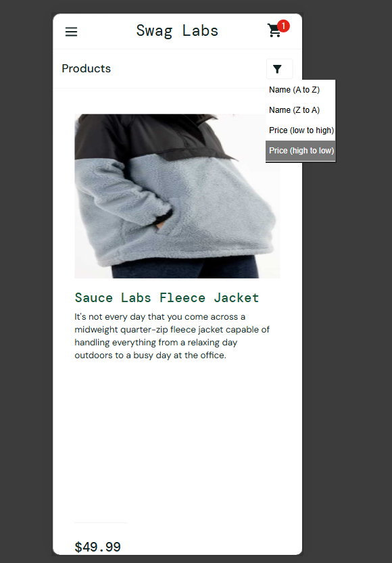
Steps: 1. Login to the application.
2. Open the Products page.
3. Click on the Filter drop-down icon.
Expected Result: The drop-down menu should be fully visible, properly aligned, and adapt its position to stay within the screen boundaries.
Actual Result: The drop-down menu is misaligned and appears partially cut off from the right side of the page.
Severity: Medium
Priority: Medium

